* 1. **Login**

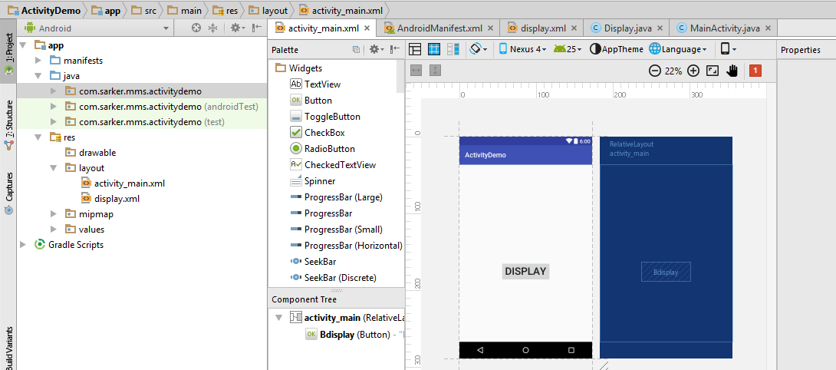

1. **MainActivity.java**

**package** com.sarker.mms.activitydemo;  
  
**import** android.content.Intent;  
**import** android.support.v7.app.AppCompatActivity;  
**import** android.os.Bundle;  
**import** android.view.View;  
  
**public class** MainActivity **extends** AppCompatActivity {  
  
 @Override  
 **protected void** onCreate(Bundle savedInstanceState) {  
 **super**.onCreate(savedInstanceState);  
 setContentView(R.layout.***activity_main***);  
 }  
 **public void** onButtonClick(View v) {  
 **if** (v.getId() == R.id.***Bdisplay***) {  
 Intent i = **new** Intent(MainActivity.**this**, Display.**class**);  
 startActivity(i);  
 }  
 }}

1. **Display.java**

**package** com.sarker.mms.activitydemo;  
  
**import** android.app.Activity;  
**import** android.os.Bundle;  
  
*/**  
 * Created by user on 11/17/2017.  
 */***public class** Display **extends** Activity{  
 @Override  
 **protected void** onCreate(Bundle savedInstanceState) {  
 **super**.onCreate(savedInstanceState);  
 setContentView(R.layout.***display***);  
 }  
}

1. **activity_main.xml**

*<?***xml version="1.0" encoding="utf-8"***?>*<**RelativeLayout xmlns:android="http://schemas.android.com/apk/res/android"  
 xmlns:tools="http://schemas.android.com/tools"  
 android:id="@+id/activity_main"  
 android:layout_width="match_parent"  
 android:layout_height="match_parent"  
 android:paddingBottom="@dimen/activity_vertical_margin"  
 android:paddingLeft="@dimen/activity_horizontal_margin"  
 android:paddingRight="@dimen/activity_horizontal_margin"  
 android:paddingTop="@dimen/activity_vertical_margin"  
 tools:context="com.sarker.mms.activitydemo.MainActivity"**>  
  
 <**Button  
 android:text="Display"  
 android:textSize="30sp"  
 android:layout_width="wrap_content"  
 android:layout_height="wrap_content"  
 android:layout_alignParentBottom="true"  
 android:layout_centerHorizontal="true"  
 android:layout_marginBottom="160dp"  
 android:id="@+id/Bdisplay"  
 android:onClick="onButtonClick"** />  
</**RelativeLayout**>

1. **display.xml**

*<?***xml version="1.0" encoding="utf-8"***?>*<**LinearLayout xmlns:android="http://schemas.android.com/apk/res/android"  
 android:layout_width="match_parent"  
 android:layout_height="match_parent"**>  
  
 <**TextView  
 android:text="Our new activity has started"  
 android:textSize="20sp"  
 android:layout_width="wrap_content"  
 android:layout_height="wrap_content"  
 android:id="@+id/textView2"** />  
</**LinearLayout**>

1. **AndroidManifest.xml**

*<?***xml version="1.0" encoding="utf-8"***?>*<**manifest xmlns:android="http://schemas.android.com/apk/res/android"  
 package="com.sarker.mms.activitydemo"**>  
  
 <**application  
 android:allowBackup="true"  
 android:icon="@mipmap/ic_launcher"  
 android:label="@string/app_name"  
 android:supportsRtl="true"  
 android:theme="@style/AppTheme"**>  
 <**activity android:name=".MainActivity"**>  
 <**intent-filter**>  
 <**action android:name="android.intent.action.MAIN"** />  
  
 <**category android:name="android.intent.category.LAUNCHER"** />  
 </**intent-filter**>  
 </**activity**>  
 <**activity android:name=".Display"**></**activity**>  
 </**application**>  
  
</**manifest**>

* 1. **Login**